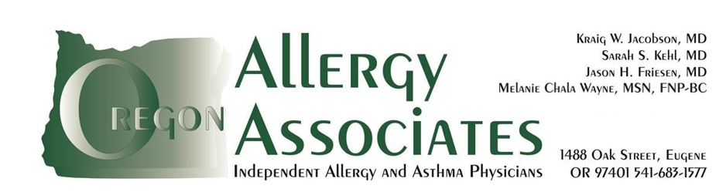

BAKED MILK CHALLENGE WITH RECIPE

The goal for a baked milk food challenge is to eat a known quantity of milk in a baked product, such as a cake or muffin.
Prepare for the Food Challenge
- Do not give antihistamines for 5 days before the food challenge.
- Continue other allergy and asthma medications as usual.
- If your child is sick on the day of the food challenge, call to reschedule the procedure
- On the day of the challenge, try not to eat for at least 4 hours before appointment. If unable, a light meal 2 hours before is acceptable.
RECIPE:

- 1 cup of milk
- 2 tbsp canola oil
- 1 tsp vanilla extract
- 1 egg* or 1 ½ tsp gg replacer if child is allergic to egg (Note: We use Ener-G brand egg replacer)
- 1 ¼ cups all-purpose flour (wheat) or Gluten free mix
- ½ cup sugar
- ¼ tsp salt
- 2 tsp baking powder

- Preheat oven to 350 degrees F
- Line a muffin pan with 6 muffin liners
- Stir together the liquid ingredients until well combined: milk, canola oil, vanilla extract, egg or egg replacer (although the egg replacer is a dry ingredient, please add at this step) Set aside
- In a separate mixing bowl, mix together the dry ingredients (flour, sugar, salt, baking powder)
- Add liquids ingredients to dry all at once and gently stir with a wooden spoon (about 15-20 light strokes) until wet and dry ingredients are just combined. Do not over stir. Some small lumps may remain.
- Divide the batter into the 6 prepared muffin liners. Depending on the size of your muffin tin, you may need to fill the muffin liners all the way to the top.
- Bake 30-35 min or until golden brown and firm to the touch. Cool completely before serving

**If you make more than 6 muffins, please note how many muffins you made and bring at least 2 muffins with you on the day of the challenge

